**Multi-Factor Authentication (MFA)**

This SOP outlines the Multi-Factor Authentication (MFA) process, which is exclusively available to Store Managers (SM) for accessing the SalesBuddy platform. MFA enhances security by multiple forms of authentication to ensure that only authorized individuals can log in.

**Process Overview:**

The MFA process is designed to provide an additional layer of security for Store Managers when accessing the SalesBuddy platform. Here are the steps to follow:

* **First-Time Login (For New Users):**

**Step1:** If you are logging in for the first time, go to the SalesBuddy platform by visiting <https://salesbuddyuat.titan.in/ww/login>

**Step2:** on the login page, select your role as "Store Manager".

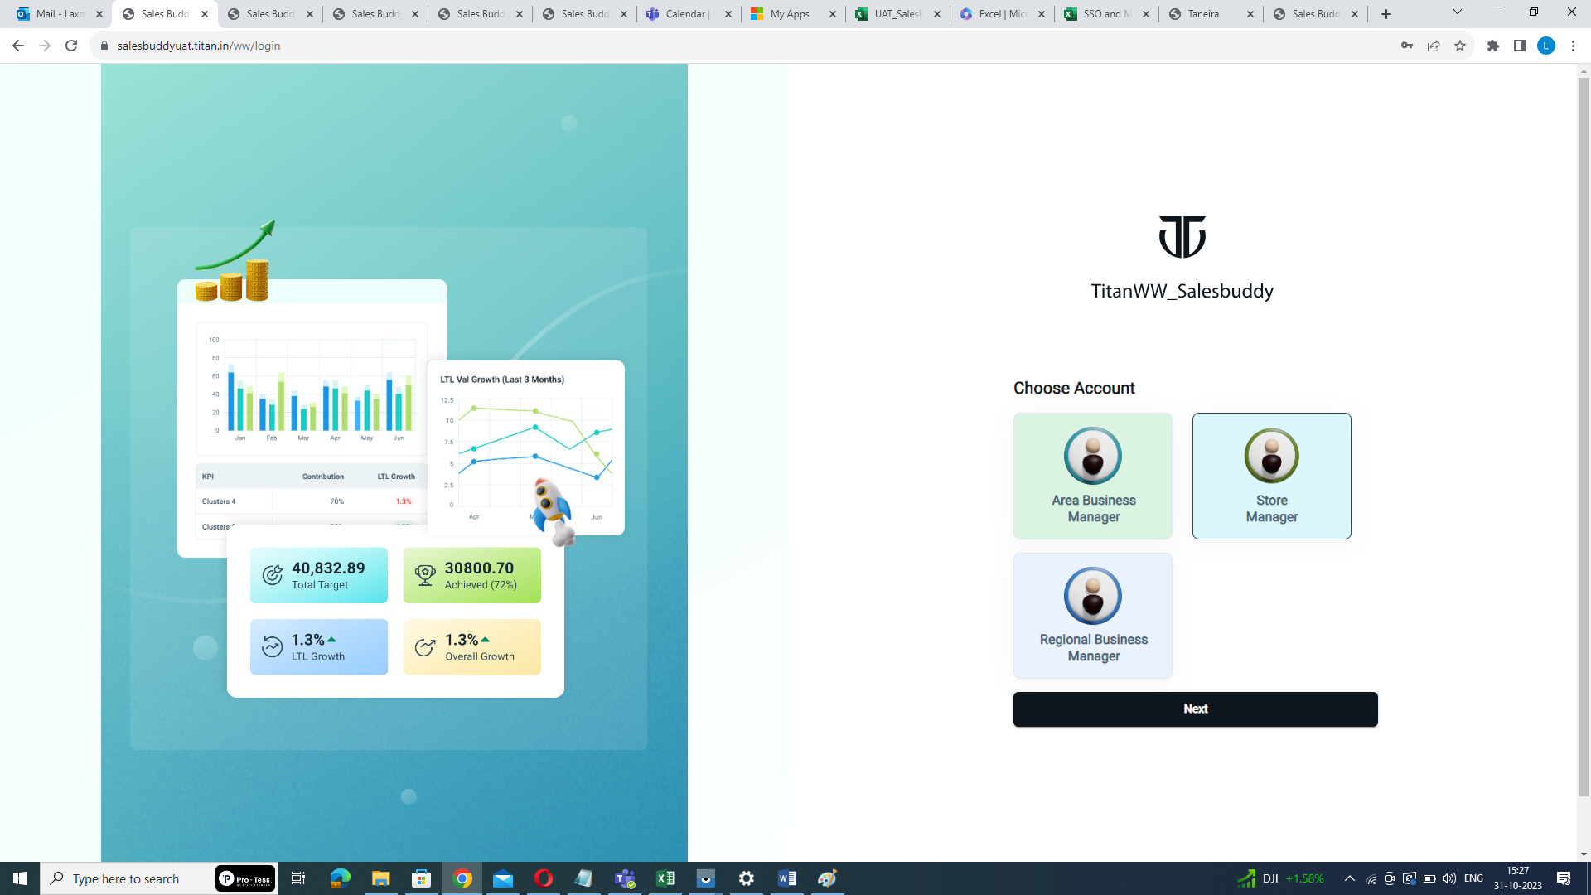

Click here

**Step3: Click "Next"**

Click "Next" to proceed. This action will take you to the MFA page.



Click here

**Step4: MFA Setup (First-Time Users):**

* Download and install the "Microsoft Authenticator" app on your mobile device from the Google Play Store or Apple App Store.
* Open the Microsoft Authenticator app and tap the "+" button to add an account.
* Choose "Work or School account" from the options.
* Click on "Scan a QR Code". Use the app to scan the QR code image provided on the MFA page.

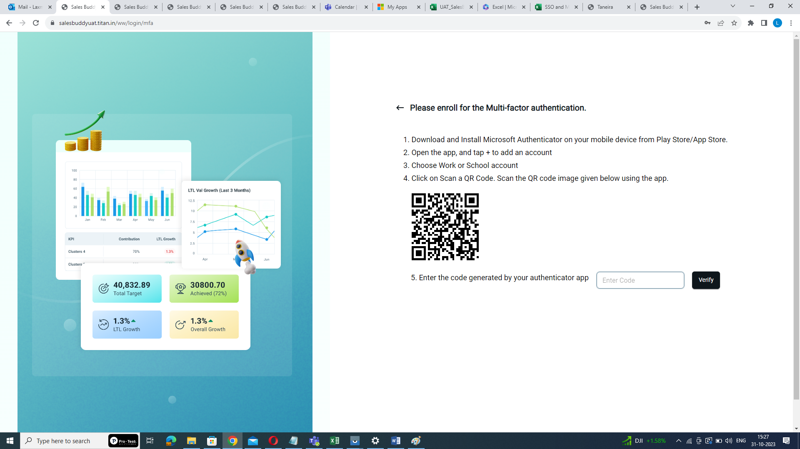

Scan this QR Code

* The app will generate a time-sensitive code. Enter this code in the space provided on the MFA page (note: the OTP is valid for only 30 seconds).



Enter auto generated OTP here

* Click the "Verify" button. After verification, you will be redirected to the home page

of the SalesBuddy platform.



Click here

* **Subsequent Logins (After MFA Setup):**

If you have completed the MFA setup, you can directly follow these steps for subsequent logins

**Step1:** open your web browser and go to <https://salesbuddyuat.titan.in/ww/>

**Step2:** on the login page, select your role as "Store Manager".



Click here

**Step3:** Click "Next" to proceed.

**:**

Click here

**Step4:** Now, you will be prompted to enter the code displayed on the Microsoft Authenticator app on your mobile device (note: the OTP is valid for only 30 seconds).

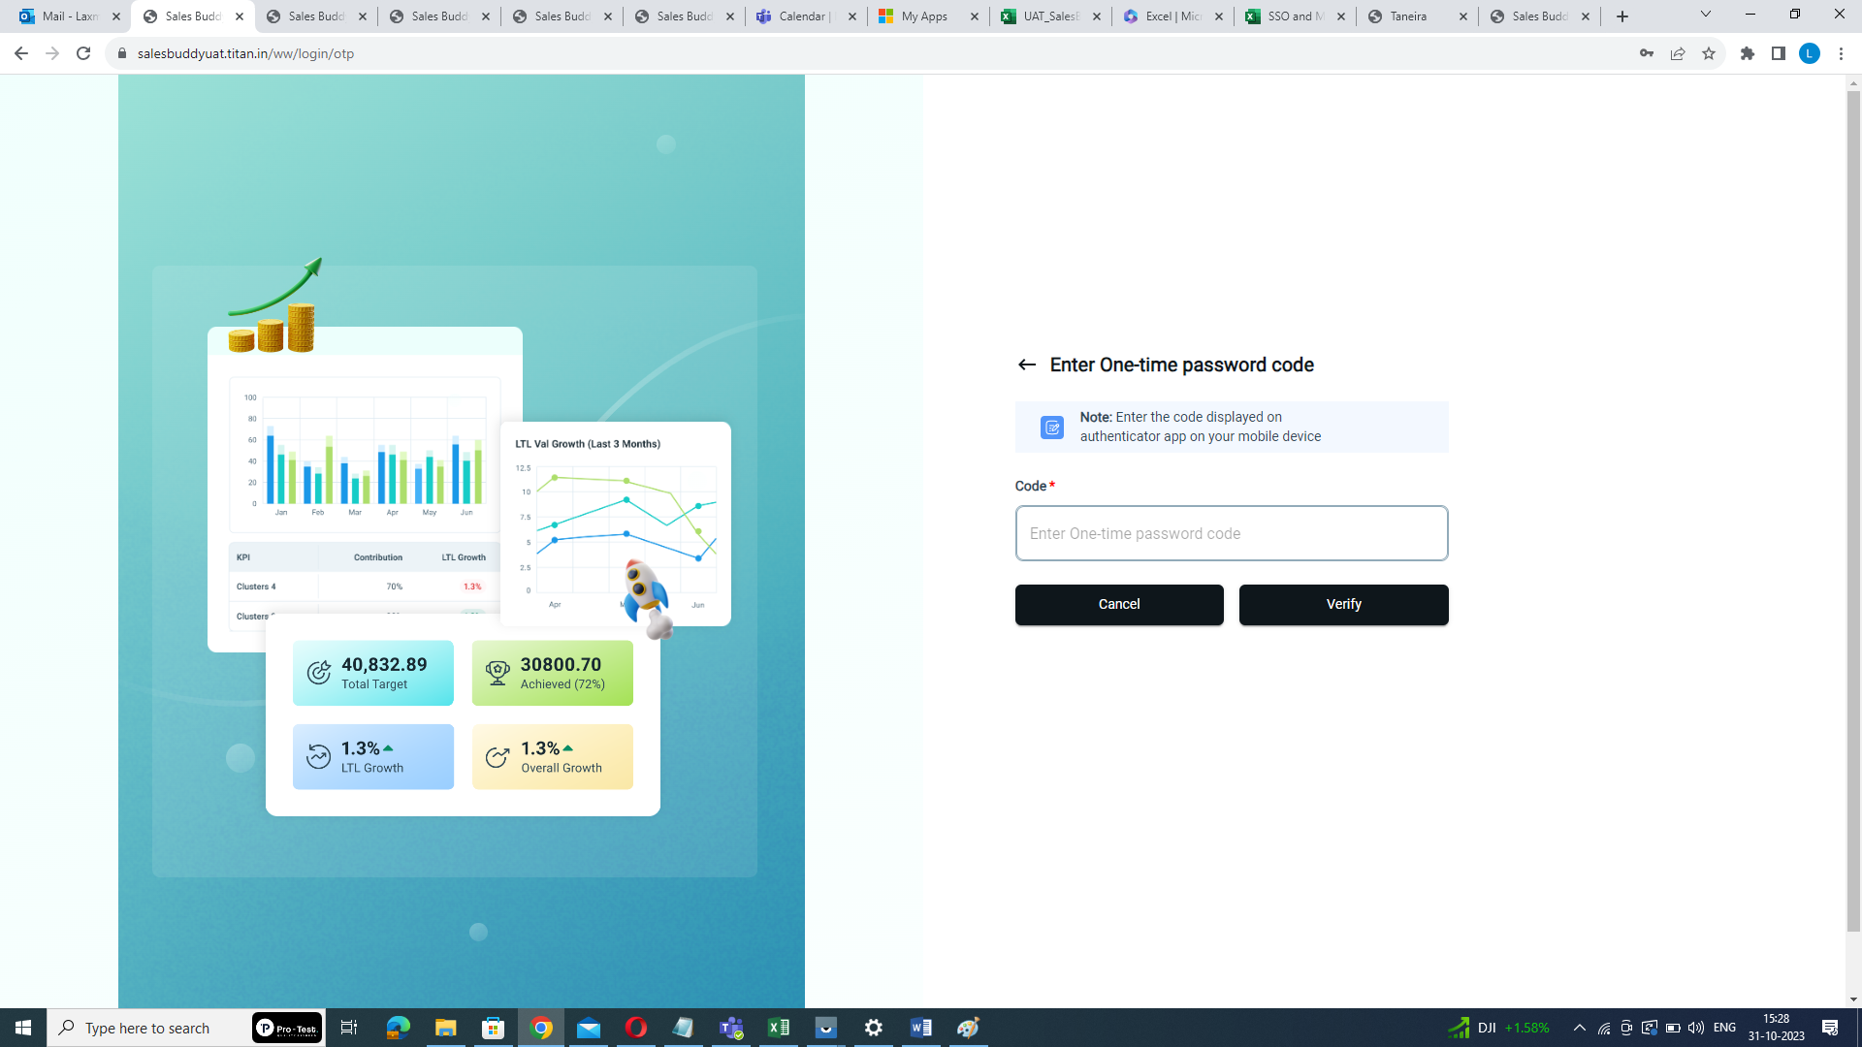

Enter auto generated OTP

**Step5:** Click "Verify", and this will take you to the home page of the SalesBuddy platform.



Click here

Following these step-by-step instructions, Store Managers can effectively set up and utilize Multi-Factor Authentication (MFA) to enhance the security of accessing the SalesBuddy platform. The MFA process adds an extra layer of security by requiring Store Managers to authenticate their identity using a time-sensitive code generated by the Microsoft Authenticator app. This helps protect sensitive information and ensures that only authorized users can access the platform.